**Name:___________________________________ /22**

**Year 10 Science**

**DNA Mini Test**

1a Label the following diagram: 4

[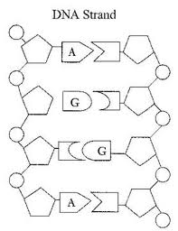](http://www.google.com.au/url?sa=i&rct=j&q=&esrc=s&frm=1&source=images&cd=&cad=rja&docid=LrUXW_twbDKvrM&tbnid=sF0L20GrUnmpVM:&ved=0CAUQjRw&url=http://www.psd202.org/pshs/depts/science/Mezger/DNA%20STUDY%20GUIDE-biology.htm&ei=KgYbUcGWE6LwmAX0uYCIDw&bvm=bv.42261806,d.dGI&psig=AFQjCNGJR7wsixjE--42qoHAb7q2ZhsV3w&ust=1360811870892519)

1b Fill in the missing letters on each of the bases 2

1c How did you know which letter to write? 1

2a What do the following letters stand for? 4

**A**

**G**

**C**

**T**

2b What does DNA stand for? 1

3 The diagram below shows *a gene, a chromosome, the nucleus of a cell and a strand of DNA*. Label each of the diagrams correctly 4

[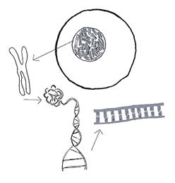](http://www.google.com.au/url?sa=i&rct=j&q=&esrc=s&frm=1&source=images&cd=&cad=rja&docid=t-qDr_ZowQECLM&tbnid=wQ1Gi_v61gurdM:&ved=0CAUQjRw&url=http://www.geneticalliance.org.uk/genesandyoudna.htm&ei=OgcbUePJCM2ikAWzrYGYCw&bvm=bv.42261806,d.dGI&psig=AFQjCNHD6EHFpc_Hpn2ALNEspVIxPkwm4g&ust=1360812171836144)

4a What is a gene? 1

4b How many chromosomes do most human cells contain? 1

4c Which cells contain a different number? 2

4d Why? 2